

**AMERICAN INTERNATIONAL UNIVERSITY-BANGLADESH Faculty of Engineering Laboratory Report Cover Sheet**

***Students must complete all details except the faculty use part.***

|  |
| --- |
| Please submit all reports to your subject supervisor or the office of the concerned faculty. |
|  |
| **Laboratory Title:** Implementation of rectifier circuits and analysis of logic gate [OR gate] and justification of the analysis with respect to simulated and experimental data (followed by given constraints).  **Experiment Type**: Mid OEL **Due Date:** 28/02/2023  **Course Code:** EEE2104 **Course Name:** ELECTRONIC DEVICES LAB **Semester:** 2022-2023, Spring  **Section:** X  **Course Instructor:** DR. MD. KAMRUL HASSAN  **Degree Program:** B.Sc. in CSE |

**Declaration and Statement of Authorship:**

1. I/we hold a copy of this report, which can be produced if the original is lost/ damaged.
2. This report is my/our original work and no part of it has been copied from any other student’s work or from any other source except where due acknowledgement is made.
3. No part of this report has been written for me/us by any other person except where such collaboration has been authorized by the lecturer/teacher concerned and is clearly acknowledged in the report.
4. I/we have not previously submitted or currently submitting this work for any other course/unit.
5. This work may be reproduced, communicated, compared and archived for the purpose of detecting plagiarism.
6. I/we give permission for a copy of my/our marked work to be retained by the institution for review and comparison, including review by external examiners.

**I/we understand that** 7. Plagiarism is the presentation of the work, idea or creation of another person as though it is your own. It is a form of cheating and is a very serious academic offence that may lead to expulsion from the University. Plagiarized material can be drawn from, and presented in, written, graphic and visual form, including electronic data, and oral presentations. Plagiarism occurs when the origin of the material used is not appropriately cited.

8. Enabling plagiarism is the act of assisting or allowing another person to plagiarize or copy your work

Group Number (if applicable): **02** Individual Submission Group Submission



|  |  |  |  |  |
| --- | --- | --- | --- | --- |
| **No.** | **Student Name** |  | **Student ID** |  |
| **Submitted by:** MIMJAMAM UL HAQUE MONMOY | |  |  |
| **1** | Rakesh Karmaker |  | 22-46862-1 |
| **2** | Urmi Karmakar |  | 22-47163-1 |
| **3** | RAIYAN SAYEED |  | 22-46494-1 |
| **4** | TAMANNA NASIR NISHAD |  | 22-46497-1 |
| **5** | MIMJAMAM UL HAQUE MONMOY |  | 22-46476-1 |
| **6** | JINIA SULTANA SAMA |  | 22-46301-1 |  |
| ***For faculty use only:***    **Faculty comments** | | **Total Marks:** | **Marks Obtained:** |  |
|  |  |

**TABLE OF CONTENTS**

|  |  |
| --- | --- |
| **TOPICS** | ***Page no*.** |
| **I. Cover Page** | 1 |
| **II. Table of Contents** | 2 |
| **1. Introduction** | 3 |
| **2. Objective** | 3 |
| **3. Theory** | 3-4 |
| **4. Simulations** | 5-6 |
| **5. Apparatus** | 7 |
| **6. Procedure** | 7 |
| **7. Experimental Data** | 8 |
| **8. Analysis** | 9-10 |
| **9. Discussion** | 11 |
| **10. Conclusion** | 11 |
| **11. Reference** | 11 |

**Name of the Experiment:** Implementation of rectifier circuits and analysis of logic gate [OR gate] and justification of the analysis with respect to simulated and experimental data (followed by given constraints).

1. **Introduction:**

We know, a diode can rectify an AC voltage and convert it into a DC voltage. And by using a Full-wave bridge rectifier we can convert an AC voltage to a DC voltage during both half cycles of the input AC voltage. But even after rectification, an exact smooth DC voltage cannot be obtained. To make the output DC voltage stable, we use a capacitor or a filtering circuit. And by using this obtained DC voltage as the input of a logic circuit, specifically an OR gate, we would be able to understand the working principles and truth table of an OR gate.

1. **Objective:**

In this experiment, we will implement a Full-wave Bridge rectifier circuit and using the obtained DC voltage, we will construct and analyze an OR gate.

1. **Theory:**

**Working Principle of Full-Wave rectifier:**

The Bridge rectifier is a circuit, which converts an AC voltage to a DC voltage using both half cycles of the input AC voltage. The Bridge rectifier circuit is shown in the following figure:

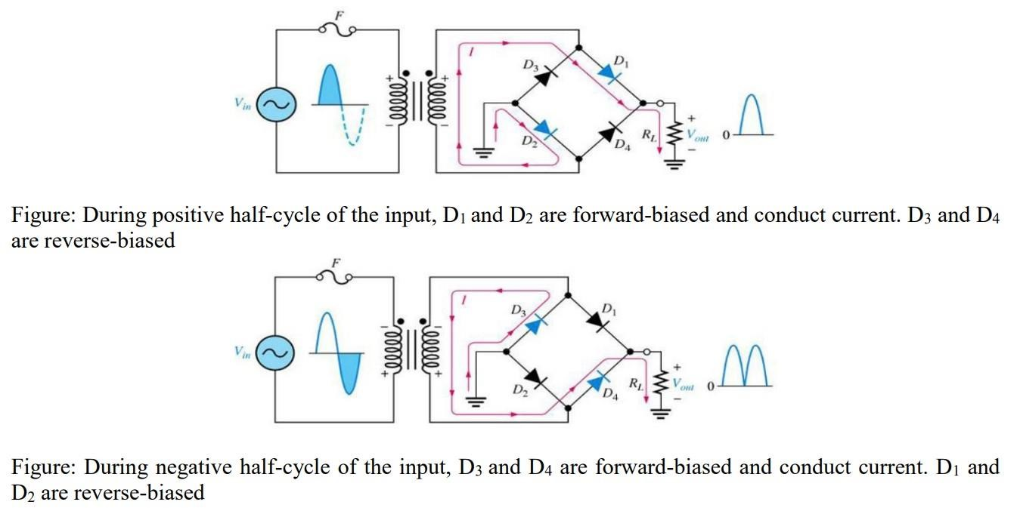

The circuit has four diodes connected to form a bridge. The AC input voltage is applied to the diagonally opposite ends of the bridge. The load resistance RL is connected between the other two ends of the bridge. For the positive half cycle of the input AC voltage, diodes D1 and D2 conduct, whereas diodes D3 and D4 remain in the OFF state. The conducting diodes will be in series with the load resistance RL and hence the load current flows through RL. For the negative half cycle of the input AC voltage, diodes D3 and D4 conduct whereas, D1 and D2 remain OFF. The conducting diodes D3 and D4 will be in series with the load resistance RL and hence the current flows through RL in the same direction as in the previous half cycle. Thus, a bi-directional wave is converted into a unidirectional wave.

**Working principle of an OR gate:**

Logic gates are the elementary building blocks of a digital circuit. They are the practical applications of Boolean Algebra. These logic gates or circuits take one or more inputs and generally give one output. OR gate is one of the basic logic gates. An OR gate operates on two or more inputs and gives one output. It gives a high output (1) if any of the inputs are high (1) and a low output (0) when all the inputs are low (0).

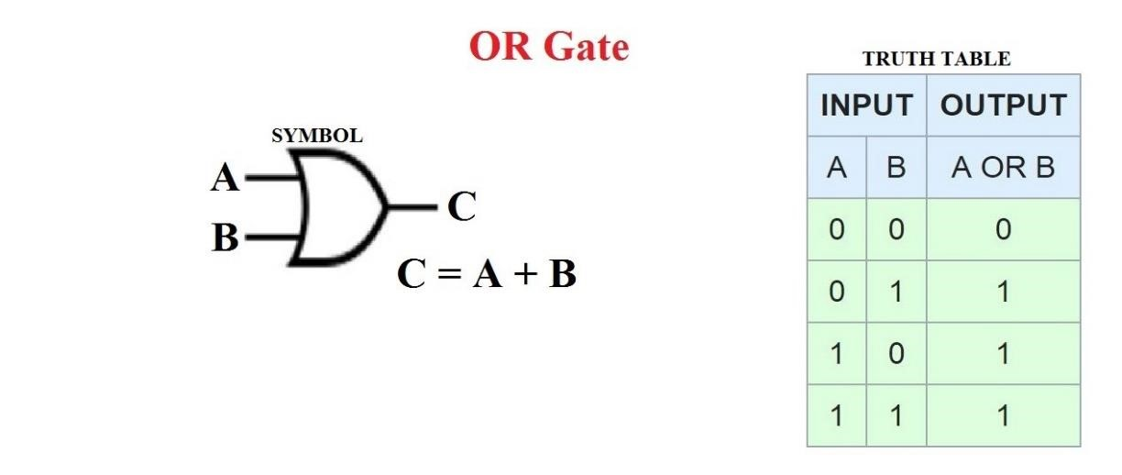

**Figure:** OR gate and its truth table.

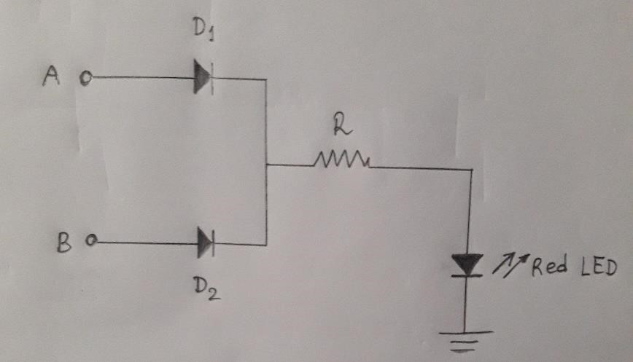

**Figure:** Implementation of OR gate using diodes.

In the above figure, if both A and B are at 0 volts, no current will flow through the diodes D1 and D2. Therefore, no current will flow through the LED. So, the LED will be “off”. If A is “on” and B is “off” (0 V), the current will flow only through D1 but not D2. The current passing through D1 will then go through the resistor, R and will then turn the LED “on”. Similarly, if A is “off” (0 V) and B is “on”, the current will only pass through D2. After going through the resistor R, it will finally turn the LED “on”. Now, if both A and B are “on”, current will pass through both the diodes and, hence turn the LED “on”. This is how an OR gate implemented by diodes works.

1. **Simulations:**

Full-wave bridge rectifier without capacitor/filter circuit:

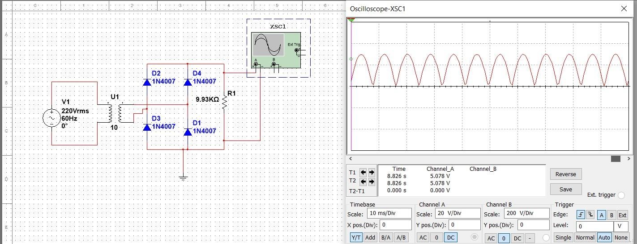

Full-wave bridge rectifier after using capacitor:

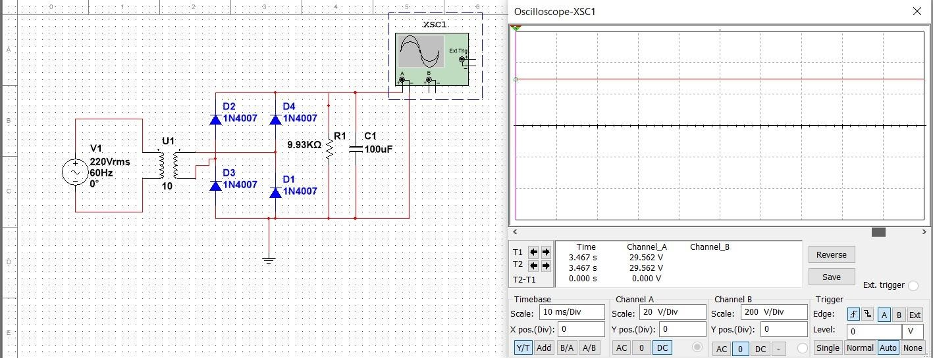

“On” states of the LED:

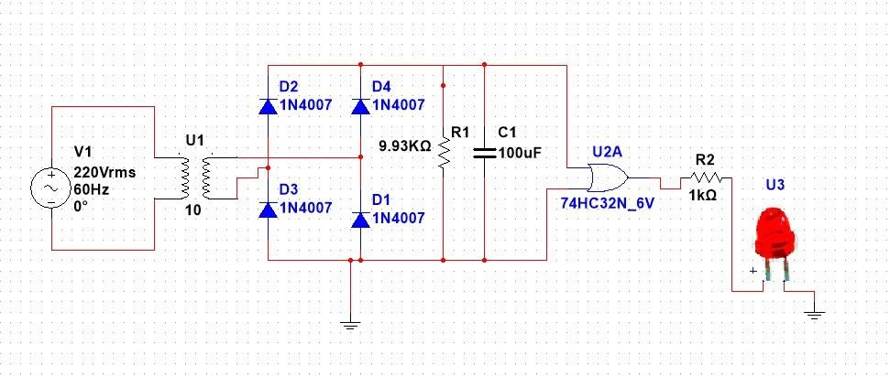

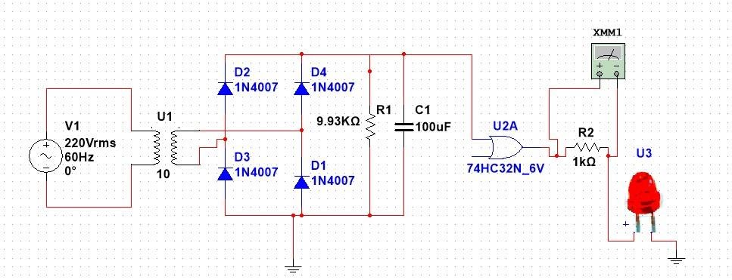



“Off” state:

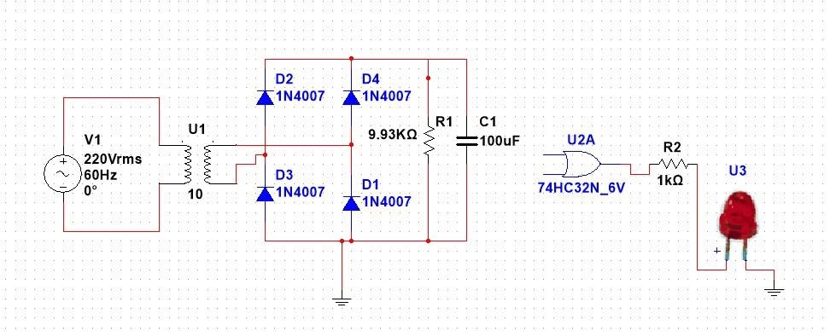

1. **Apparatus:** 
   1. Four diodes
   2. Resistors – 9.93kΩ, 1kΩ
   3. A Project Board
   4. An Oscilloscope
   5. A Multimeter
   6. Transformer 220V/14V/7V
   7. 100µF capacitor
   8. Connecting wires
   9. DC Power Supply
   10. An IC
   11. A Red LED
2. **Procedure:**

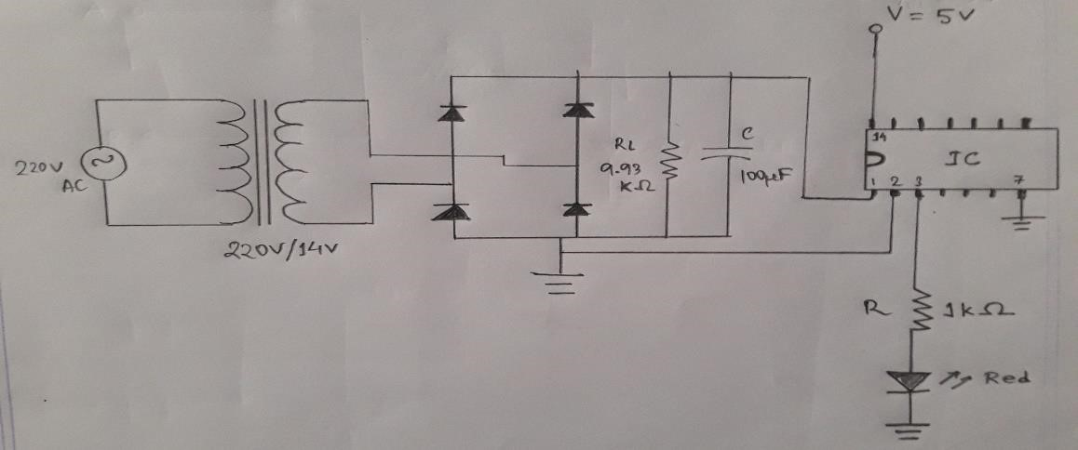

**Figure:** Circuit Diagram

* 1. At first, we made a full-wave bridge rectifier circuit according to the figure but without the capacitor.
  2. We connected the oscilloscope to observe the wave shape of the output voltage.
  3. We checked using the Multimeter whether or not we got the correct output voltage by comparing it with the oscilloscope reading.
  4. Next, we turned off the power supply and connected a 100µF capacitor across the load resistor. We used this capacitor to make the rectified DC voltage stable. We observed with the help of the oscilloscope.
  5. For the sake of convenience, we used an OR gate IC to make the OR gate logic circuit. We connected the obtained stable rectified DC voltage to the 1st pin of the IC using a connecting wire, the 2nd and 7th pins to the ground, the 3rd pin to a resistor and a Red LED which are connected in series (for output), and the 14th pin to a 5V DC power supply.
  6. After setting up the OR gate logic circuit according to point (e), we observed that the LED light turned “on”. If we turned “off” any one of the AC or DC power supplies, the LED still remained “on”. But only when turned both the power supplies “off”, then the LED was “off”.
  7. Thus, this supports the working principle of an OR gate.

1. **Experimental Data:**

**Truth table for OR gate:**

|  |  |  |
| --- | --- | --- |
| **In** | **put** | **Output** |
| **A** | **B** | **LED** |
| When stable rectified DC voltage is  “off” | When the DC voltage from the power supply is “off” | OFF |
| When stable rectified DC voltage is  “off” | When the DC voltage from the power supply is “on” | ON |
| When stable rectified DC voltage is  “on” | When the DC voltage from the power supply is “off” | ON |
| When stable rectified DC voltage is  “on” | When the DC voltage from the power supply is “on” | ON |

1. **Analysis:**

Waveform of full-wave bridge rectifier when capacitor is not used:

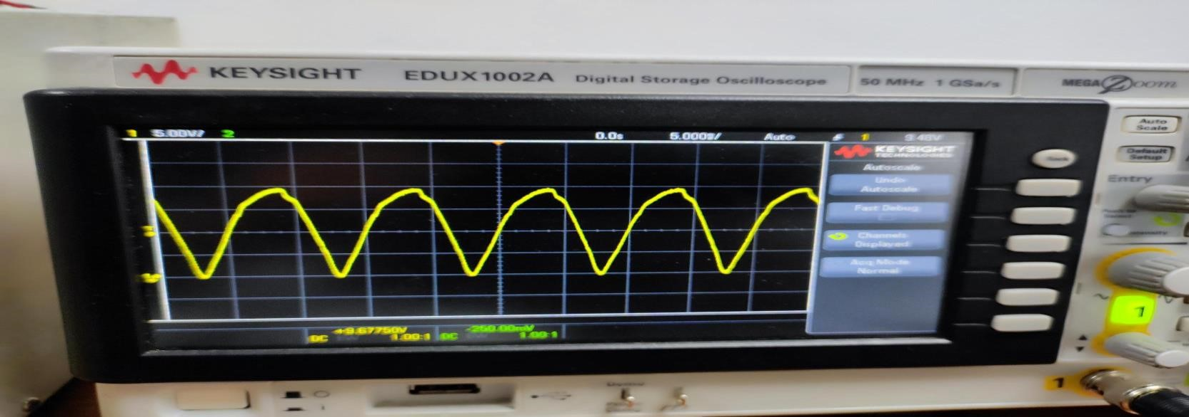

Waveform of full-wave bridge rectifier when capacitor is used:

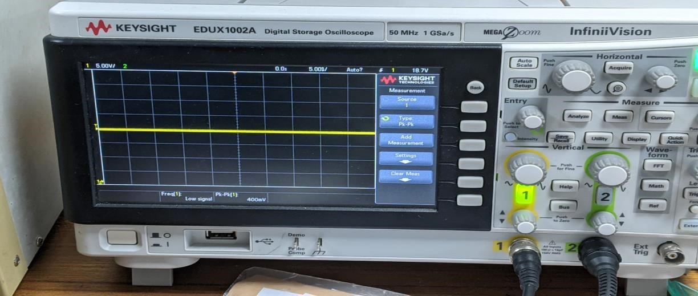

When LED is “on”:

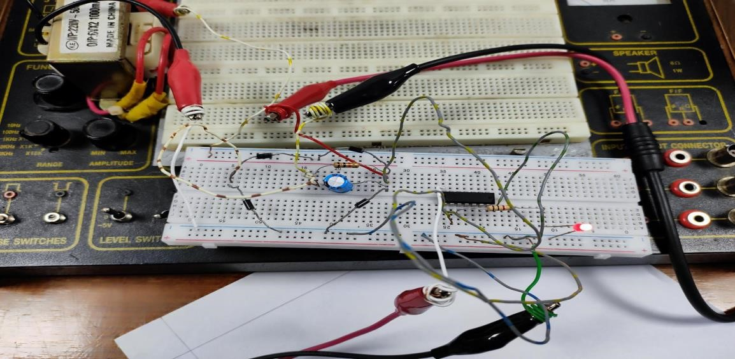

When LED is “off”:

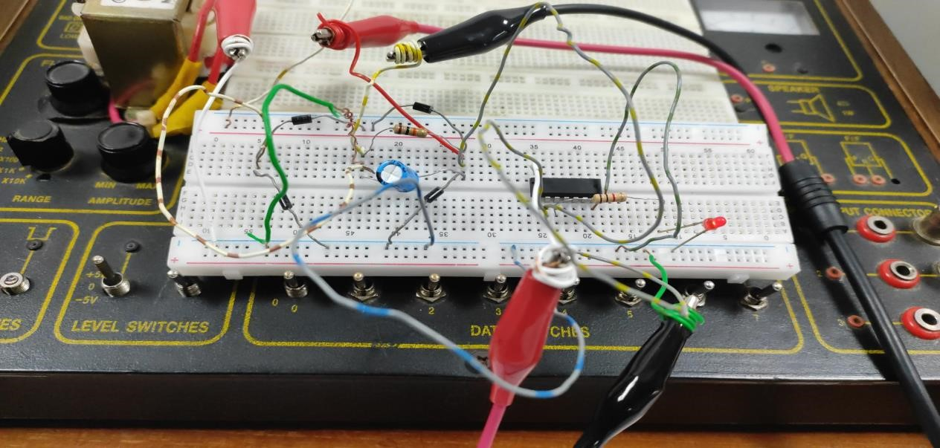

Full setup:

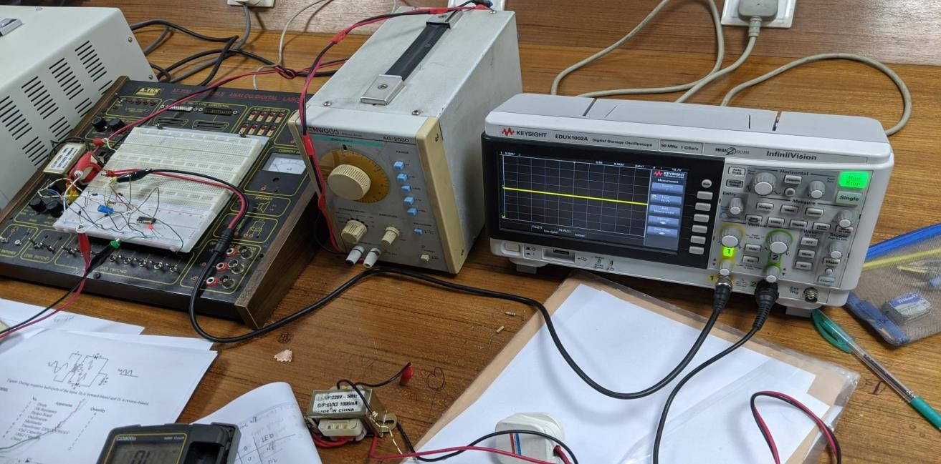

Page

1. **Discussion:**

As we know, to convert an AC voltage to a DC voltage a rectifier is necessary. And to completely convert both half cycles, a full-wave rectifier is needed. To make the obtained rectified DC voltage stable, a filter circuit or capacitor is used. OR gate is one of the fundamental logic gates that take two or more inputs and give one output. In this experiment, we tried to construct a full-wave bridge rectifier circuit and implement a basic OR using the obtained stable rectified DC voltage from the rectifier as input. After setting up the apparatus according to the procedure we observed the waveforms on the oscilloscope and checked the logic of the OR gate. We also tried to simulate the experiment on NI

Multisim.

It can be seen by comparing the simulation and experimental observations that, while the logic of the OR gate is the same, the waveforms seen on the oscilloscope are not exactly the same. This occurs due to a number of factors we faced while conducting the experiment. We know that we get a non-linear DC signal from the full-wave bridge rectifier without the capacitor or filter circuit. But even after using the capacitor, while the DC signal may seem linear it’s not completely linear. That is why the experimental waveshapes and positions may vary a bit from the simulated ones. Again, due to the nonlinearity of the output rectified DC signal, the output voltage is somewhat less than the input AC voltage. Other errors include instrumental and personal errors such as, not securely placing the components on the trainer board, the probes of the oscilloscope being loose, the parameters of the oscilloscope not being set correctly etc. These are the errors we faced while conducting the experiment.\

1. **Conclusion:**

Despite facing a number of errors while experimenting, it can be said that we were successful in implementing a rectifier circuit and analyzing the OR gate logic circuit.

1. **References:** 
   1. Robert L. Boylestad, Louis Nashelsky, Electronic Devices and Circuit Theory, Ninth Edition, 2007-2008.
   2. Adel S. Sedra, Kennth C. Smith, Microelectronic Circuits, Saunders College Publishing, 3rd ed., ISBN: 0-03051648-X, 1991.
   3. David J. Comer, Donald T. Comer, Fundamentals of Electronic Circuit Design, john Wiley & Sons Canada, Ltd.; ISBN: 0471410160, 2002.
   4. American International University–Bangladesh (AIUB) Electronic Devices Lab Manual.
   5. Bilal, “Introduction to OR Gate”, [project123.com,](http://www.project123.com/)<https://projectiot123.com/2019/05/25/introduction-to-or-gate/>(May 25, 2019)

Page